***Original article***

Effects Of High-Dose All-Trans-Retinoic Acid on Tibial Growth of Young Male Albino Rats

Nada Khaled Atef Essa 1*, Ibrahim Sayed Ahmed Zamzam 1, Maha Mohamed Mokhtar 1, Marwa M. M. Fawzy 1, Nagah ElSayed Mohamed Ali 1

1 Forensic Medicine and Clinical Toxicology, Faculty of Medicine, Benha University

**Abstract**

**Background:** All-trans-retinoic acid (ATRA), an active metabolite of vitamin A, plays a significant role in controlling various physiological processes, including embryonic development and epithelial differentiation. ATRA is utilized as a chemotherapeutic agent for treating of Acute Promyelocytic Leukemia (APL) in pediatric patients. Besides its efficacy in APL therapy, ATRA is extensively used in the treatment of various skin diseases such as psoriasis, skin cancer, acne, and ichthyosis.

**Aim:** This study aimed to assess the impact of high-dose ATRA on tibial growth by measuring serum growth hormone “GH,” histomorphometric measurements of tibia, and histopathological examination of tibia in young male albino rats.

**Methods**: This experimental study included 54 male albino rats, aged 6 weeks, divided into three groups: Group I and Group II served as control groups, whereas Group III was administered ATRA treatment (40 mg/kg/day of ATRA suspension administered via gavage, dissolved in 1 cc of corn oil at a concentration of 10 mg/ml, with an oral LD50 of 2 g/kg). Each group was subdivided into three subgroups, each comprising six rats. The research was submitted to the Research Ethics Committee of the Faculty of Medicine at Benha University. The study assessed the effects of ATRA treatment on serum growth hormone, weight, tibial length, nose-tail length, outer cortical bone thickness, relative bone resorption eroded surface percentage, osteoclast count, and osteoblast count compared to control groups.

**Results:** There were no notable variations in these parameters among the control groups. In addition, there were no significant differences in osteoblast count among all groups. The ATRA-treated groups demonstrated a significant decrease in serum GH, weight (P<0.05 to P=0.001), tibial length (P<0.05), nose-tail length (P<0.05), and outer thickness of cortical bone (P=0.000), as well as a highly significant increase (P=0.000) in relative bone resorption eroded surface percentage and osteoclast count.

**Conclusion:** High-dose administration of ATRA resulted in a reduction in growth measurements, including weight, tibial length, and nose-tail length with histological alterations and histomorphometric changes.

**ARTICLE INFO**

**Article history**

Received

Revised

Accepted

Published

**Keywords:** All-Trans-Retinoic acid; Tibia; Growth hormone; Bone toxicity

**I. Background**

Since the human body cannot synthesize vitamin A, it must be obtained through diet. It is an important micronutrient [1]. It is a fat-soluble vitamincategorized into two sources: preformed vitamin A or retinol, which is present in animal-based diets, and pro-vitamin carotenoid, which is found in fruit and vegetable sources [2]. Enzymes convert vitamin A into retinol, retinaldehyde, and ultimately, irreversibly, into retinoic acid (RA), which is the hormone-active form of vitamin A [3].

Retinoic acid exists in three isoforms: 9-cis retinoic acid, 13-cis retinoic acid, and ATRA. ATRA represents the predominant and most active isoform [4]. Vitamin A derivatives exist in both synthetic and natural retinoid forms. They play a crucial role in regulating various physiological functions in multiple organ systems, including development, differentiation, and immunological function [5].In physiological microenvironments, ATRA functions as an alcohol and vitamin A metabolite, significantly influencing various physiological processes, such as embryonic development and epithelial differentiation. [6].

ATRA, or all-trans retinoic acid, has been demonstrated to possess both chemotherapeutic and chemopreventive effects. The application of this agent as a differentiation inducer, whether used independently or in conjunction with other chemotherapeutic agents, represents the current standard therapeutic strategy for the treatment of pediatric acute promyelocytic leukemia (APL) and neuroblastoma (NB) [7].ATRA is not only effective in APL therapy but is also widely used in the treatment of various skin conditions, such as ichthyosis, psoriasis, acne, and skin cancer, in addition to its role in wrinkle management. The effects on cell differentiation, proliferation, and apoptosis account for this, and it is also highly effective against respiratory syncytial virus (RSV) in neonates [5]. ATRA can be associated with life-threatening adverse reactions, such as ulcers, Sweet's syndrome, myocarditis, myositis, and differentiation syndrome [8].

However, it also has short-term adverse effects, such as skin mucosal erosion and mental disorders. Furthermore, it has the potential to result in early epiphysis closure or degeneration in the long term. Additionally, the overconsumption of vitamin A has been associated with a reduction in cortical bone thickness and an increase in trabecular bone content, as well as an increase in osteoclast count and activity. This results in a low stature and the prevention of long bone growth [3].

Few studies have examined the impact of ATRA on a variety of organs, including the liver and bones. The research that identified the toxic effects of ATRA on bone was insufficient to elucidate the mechanisms of ATRA’s bone toxicity and focus on its clinical implications.

Overall, the rationale for this research emphasizes the necessity of comprehending the impact of ATRA on bone remodeling and emphasizes the potential implications for improving bone health and preventing therapeutic harm to the bone. According to our study, ATRA’s effect needs more clinical observation for its use as a chemotherapeutic and chemopreventive drug for protection against bone toxicity.

Preclinical studies using animal models, such as albino rats, play a vital part in elucidating the effects of pharmacological agents on bone physiology [9].

This experimental study aims to assess the effect of a high dose of retinoic acid in its entirety "ATRA" on tibial growth by measurement of serum growth hormone, histomorphometric measurements of the tibia, and histopathological examination of the tibia in young male albino rats.

**II. Materials and Methods**

Chemicals:

ATRA, in the form of powder with a purity of 97%, and Corn Oil were purchased from Acros Chemical Company, Belgium.

Animals:

The study included 54 male albino rats (weighing 100-150 gm) , aged 6 weeks.

Ethical consideration: The study adhered to the guidelines for the use and care of experimental animals (Clark et al., 1997). The research was submitted to the Research Ethics Committee of Benha University's Faculty of Medicine and received approval under approval code (MS-17-4-2023).

Route of administration:

Both ATRA and corn oil were given by oral gavage using a metallic cannula.

Experimental design:

This experimental study included fifty-four, 6-week-old male albino rats, which were divided into three groups: Group I and Group II served as control groups, while Group III received ATRA treatment during September 2023.

Group I (negative control group): 18 rats had unrestricted access to food and purified water, and they were all kept unaltered to measure fundamental parameters.

Group Ia: (6 rats) sacrificed after 3 days, Group Ib: (6 rats) sacrificed after 7 days, and Group Ic: (6 rats) sacrificed after 10 days.

Group II (positive control group): Eighteen rats received 0.4 ml per 100 grams of corn oil daily.

Group IIa: (6 rats) sacrificed after 3 days, Group IIb: (6 rats) sacrificed after 7 days, Group IIc: (6 rats) sacrificed after 10 days.

Group III (All-Trans-Retinoic Acid (ATRA) treated group) 18 rats (all were given 40mg/kg per day of ATRA suspension administered via gavage tube (dissolved in corn oil at a concentration of 10 mg/ml):

Group IIIa (6 rats) were sacrificed after three days, Group IIIb (6 rats) were sacrificed after seven days, and Group IIIc (6 rats) were sacrificed after ten days.

Dosage regimen and vehicle:

The dose of ATRA was 40 mg/kg/day of ATRA suspension administered by gavage (dissolved in 1 cc of corn oil at a concentration of 10 mg/ml) (Shen et al., 2022) with LD50 oral = (2g/kg) [3]. Corn oil was used to form a suspension with freshly prepared ATRA powder.

Sample size calculation :

We assumed a pooled standard deviation of 1.5 units. Therefore, a sample size of 6 for each group (totaling 54, assuming equal group sizes) is required to achieve a power of 80% and a significance level of 5% (two-sided) for detecting a true difference in means of -2.899 units in weight (i.e., 41.5 - 44.4).   
-If a random sample of 6 is selected from each population, resulting in means of 41.5 and 44.4 units for the test and reference groups, respectively, with a standard deviation of 1.5 units, there would be 80% power to conclude that the groups have significantly different means, indicated by a two-sided p-value of less than 0.05.

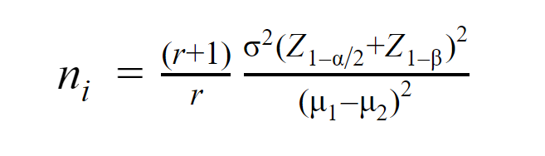The following equation was used for sample size calculations:

Sample Collection: In order to separate clear serum for biochemical analysis, blood samples were obtained by puncturing the retro-orbital plexus without the use of an anticoagulant. The tibia was removed from each leg. Removed Tibial bones were cleaned and immersed in 10% formalin to be examined histopathologically and for histomorphometric measurements.

Studied parameters:

A total of 54 six-week-old male [albino rats](https://www.sciencedirect.com/topics/biochemistry-genetics-and-molecular-biology/sprague-dawley-rat) were subjected to several recordings. The [body weights](https://www.sciencedirect.com/topics/biochemistry-genetics-and-molecular-biology/body-weight) of the rats, nose-tail lengths, and tibial bone lengths were recorded before the experiment and at the end of each group.

All groups were subjected to the following investigations:

1-Biochemical analysis:

Preparation of serum:

Blood was centrifuged at 2500 rpm for 15 minutes to extract serum after 30 minutes at ambient temperature. The serum was subsequently stored at -80 °C until further use.

The reagents were equilibrated to room temperature (20–25°C) prior to use. Standards A – G and Authority 1 and 2 were reconstituted using a dilution Buffer. Reconstituted reagents were maintained at room temperature for 15 minutes and subsequently mixed thoroughly and gently using a Vortex mixer, ensuring no foam formation. KS1 (control serum 1) and KS2 (control serum 2) were then diluted with the Dilution Buffer in the same ratio as the sample (Bielohuby et al., 2012).

The serum growth hormone (GH) of experimental rats was measured using ELISA kits. Blood samples were collected at night during the peak of GH level [3].

2- Histomorphometric measurements of Tibial bone:

Measurements of specific parameters related to the growth process were conducted for observations and morphological assessments through captured images using an OMAX camera (4x, 10x, 40x). The images were analyzed with Image-Pro Plus (Version 6.3, Media Cybernetics, Nippon Roper Co., Ltd.) image analysis software [10]. The following parameters were measured: (a) Outer cortical bone thickness: the outer cortical bone's mean width. A perpendicular line was drawn from the periosteum to the endosteum in order to quantify this.

(b) Relative bone resorption eroded surface (%): proportion of compact bone surface exhibiting resorption-specific characteristics, such as surfaces containing or lacking osteoclasts. In addition, the length of eroded trabecular surface% and total length of trabecular surface were measured. (c) The count of osteoblasts in an area was equal to 500 µm2. The cells were categorized as follows: Osteoblasts were previously characterized as large, multinucleated cells involved in bone resorption, while osteoclasts were considered mononuclear, cuboidal, or columnar cells with a high content of basophilic cytoplasm, serving as bone lining cells.

3-Histopathological examination of Tibial bone:

Histopathological examinations of the tibia were conducted on all experimental rats, and the slides were analyzed at the Pathology Department of the Animal Health Research Institute, Zagazig Laboratory.

All tibial bone tissue sections obtained from experimental rats were prepared using the paraffin technique. Paraffin sections were cut to a thickness of 5 μm and subsequently stained with eosin and hematoxylin. Samples were examined under a light microscope (Olympus, Japan) after staining.

Statistical analysis:

PSW (20), released in 2011, was used for data input, coding, and analysis (IBM Corp.). The 24.0 version of IBM SPSS Statistics for Windows. NY / Armonk: IBM Corp.

The study's data were of the quantitative variety. The means ± were utilized to express parametric quantitative data. The median, lowest, and maximum standard deviations for non-parametric quantitative data. Data normality was examined using the Shapiro-Wilk and Kolmogorov-Smirnov tests. According to the regularity of distribution, the ANOVA test (F) (Analysis of Variance) or Wallis and Kruskal (KW) test was used to test the significance of numerical information across three groups. In addition, the Mann Whitney or Independent t-test (U) compared the means of the two groups for pair-wise comparison. The Repeated ANOVA test (F) and the Friedman test (F(X2)) were used for the three repeated measures of numeric variables. A paired t-test or the Wilcoxon signed ranks test was utilized for repeated pair-wise comparisons based on the normality of the data. The area under the curve (AUC), sensitivity, specificity, negative predictive value (NPV), positive predictive value (PPV), and accuracy of the receiver operating characteristic (ROC) curve are analyzed for various cutoffs of a diagnostic test or marker to assess its effectiveness as a diagnostic tool. Our data established a 95% significance threshold, thus a p-value greater than 0.05 was regarded as non-statistically significant (Peacock, 2020).

**III. Results**

The serum level of growth hormone (GH) is displayed in Table 1. With respect to the control groups, the mean value of serum growth hormone (GH) does not exhibit a significant difference between Group Ia (negative control at 3 days), Group Ib (negative control at 7 days), Group Ic (negative control at 10 days), Group IIa (positive control at 3 days), Group IIb (positive control at 7 days), and Group IIc (positive control at 10 days). In comparison to the negative and positive control groups, Group IIIa (ATRA treated at 3 days), Group IIIb (ATRA treated at 7 days), and Group IIIc (ATRA treated at 10 days) exhibit a substantial decrease in the mean value of serum growth hormone. However, there was no significant difference (P>0.05) in the mean value of serum growth hormone within Group IIIc (ATRA treated at 10 days) compared to Group IIIa (ATRA treated at 3 days) and IIIb (ATRA treated at 7 days). In terms of weight, the control groups: Group Ia (negative control at 3 days), Group Ib (negative control at 7 days), Group Ic (negative control at 10 days), Group IIa (positive control at 3 days), Group IIb (positive control at 7 days), and Group IIc (positive control at 10 days) exhibited a non-significant difference in the mean weights. Regarding the ATRA-treated groups, Group IIIa (ATRA treated at 3 days) exhibited a significant decrease in the mean weight (P<0.05). Group IIIb (ATRA treated at 7 days) and Group IIIc (ATRA treated at 10 days) exhibited an extremely substantial mean weight decline (P=0.001) in the treatment group. The mean weight of Group IIIc (ATRA treated at 10 days) was significantly lower (P<0.05) than that of Group IIIa (ATRA treated at 3 days) and IIIb (ATRA treated at 7 days), in contrast to both the negative and positive control groups.

**Table 1: Comparison between control groups and ATRA-treated groups regarding serum level of growth hormone (GH) and weight:**

|  |  |  |  |  |
| --- | --- | --- | --- | --- |
| Groups | GH | | | F TEST, P VALUE (ATRA Treated with corresponding control group) |
| Mean | ± SD | Range |
| Group Ia (Negative control at 3 days) | 5.59 | 0.136 | 5.625(5.4-5.77) |  |
| Group Ib (Negative control at 7 days) | 5.582 | 0.161 | 5.615(5.3-5.74) |  |
| Group Ic (Negative control at 10 days) | 5.442 | 0.163 | 5.45(5.2-5.66) |  |
| Group IIa (Positive control at 3 days) | 5.522 | 0.219 | 5.485(5.21-5.85) |  |
| Group IIb (Positive control at 7 days) | 5.43 | 0.288 | 5.51(5.04-5.740) |  |
| Group IIc (Positive control at 10 days) | 5.29 | 0.194 | 5.28(5.08-5.550) |  |
| P# = 0.531 | | | | |
| Group IIIa (ATRA treated at 3 days) | 0.98 | 0.422 | 0.863(0.549-1.760) | F=513.304 P=0.000 |
| Group IIIb (ATRA treated at 7 days) | 0.879 | 0.471 | 0.710(0.432-1.650) | F=388.816 P=0.000 |
| Group IIIc (ATRA treated at 10 days) | 0.817 | 0.228 | 0.821(0.495-1.123) | F=1072.913 P=0.000 |
| P## = 0.643 | | | | |
| Weight | | | | |
| Group Ia (Negative control at 3 days) | 137.0 | 2.098 | 137.5(134-139) |  |
| Group Ib (Negative control at 7 days) | 141.67 | 1.211 | 141.5(140-143) |  |
| Group Ic (Negative control at 10 days) | 145.33 | 1.862 | 145.0(143-148) |  |
| Group IIa (Positive control at 3 days) | 137.5 | 1.87 | 137.5(135-140) |  |
| Group IIb (Positive control at 7 days) | 141.33 | 1.966 | 140.5(140-145) |  |
| Group IIc (Positive control at 10 days) | 147.50 | 3.271 | 148.5(143-151) |  |
| P# = 0.643 | | | | |
| Group IIIa (ATRA treated at 3 days) | 134.5 | 1.87 | 134.5(132-137) | F=4.079 P=0.038 |
| Group IIIb (ATRA treated at 7 days) | 133.5 | 2.168 | 133(131-137) | F=38.322 P=0.000 |
| Group IIIc (ATRA treated at 10 days) | 129.5 | 1.871 | 129.5(127-132) | F=98.387 P=0.000 |
| P## = 0.014 | | | | |

The data are presented as,mean±SD, median (Min-Max), F: ANOVA (Analysis of Variance test), Significant at P<0.05, P<0.01 indicates highly significant (HS) P#: Control group, P##: ATRA treated group.

Table 2 shows the tibial length. Group Ia (negative control at three days), Group Ib (negative control at seven days), Group Ic (negative control at ten days), Group IIa (positive control at three days), Group IIb (positive control at seven days), and Group IIc (positive control at ten days) demonstrated non-significant variation in mean tibial length (P >0.05) compared to the control groups. In addition, Group IIIa (ATRA treated at three days), Group IIIb (ATRA treated at seven days), and Group IIIc (ATRA treated at ten days) exhibited a substantial decrease in mean (P<0.05) tibial length compared to the cohorts of positive and negative controls. In contrast, there was no statistically significant difference (P>0.05) in the mean tibial length of Group IIIc (ATRA treated at ten days) compared to Group IIIa (ATRA treated at three days) and IIIb (ATRA treated at seven days). There was no significant difference between Group Ia (negative control at three days), Group Ib (negative control at seven days), Group Ic (negative control at ten days), Group IIa (positive control at three days ), Group IIb (positive control at seven days), Group IIc (positive control at ten days) (P >0.05) in mean values of nose-tail length. In the ATRA-treated groups, Group IIIa (ATRA treated at 3 days) demonstrated a non-significant difference (P>0.05) in the mean value of nose-tail length. Group IIIb (ATRA treated at seven days) showed a significant reduction (P<0.05) in mean nose-tail length when compared to both the negative and positive control groups. Meanwhile, group IIIc (ATRA treated at 10 days) presents. The treatment group demonstrated a statistically significant reduction (P<0.05) in the mean nose-tail length compared to both the negative and positive control groups. There was no significant difference (P>0.05) in the mean nose-tail length of Group IIIc (ATRA treated at ten days) when compared to Group IIIa (ATRA treated at three days) and Group IIIb (ATRA treated at seven days).

**Table 2: Comparison between control groups and ATRA-treated groups regarding Tibial Length and Nose-Tail Length:**

|  |  |  |  |  |
| --- | --- | --- | --- | --- |
| Groups | Tibial Length | | | F TEST, P VALUE (ATRA Treated with corresponding control group) |
| Mean | ± SD | Range |
| Group Ia (Negative control at 3 days) | 2.415 | 0.054 | 2.425(2.33-2.48) |  |
| Group Ib (Negative control at 7 days) | 2.495 | 0.086 | 2.47(2.41-2.63) |  |
| Group Ic (Negative control at 10 days) | 2.548 | 0.088 | 2.57(2.40-2.65) |  |
| Group IIa (Positive control at 3 days) | 2.425 | 0.0493 | 2.43(2.35-2.48) |  |
| Group IIb (Positive control at 7 days) | 2.4667 | 0.067 | 2.44(2.40-2.56) |  |
| Group IIc (Positive control at 10 days) | 2.533 | 0.077 | 2.54(2.44-2.63) |  |
| P# = 0.674 | | | | |
| Group IIIa (ATRA treated at 3 days) | 2.305 | 0.0846 | 2.315(2.15-2.40) | F=6.389 P=0.010 |
| Group IIIb (ATRA treated at 7 days) | 2.482 | 0.058 | 2.48(2.42-2.55) | F=0.238 P=0.791 |
| Group IIIc (ATRA treated at 10 days) | 2.328 | 0.275 | 2.385(1.8-2.61) | F=3.043 P=0.087 |
| P## = 0.080 | | | | |
| Nose-Tail Length | | | | |
| Group Ia (Negative control at 3 days) | 21.067 | 0.242 | 137.5(134-139) |  |
| Group Ib (Negative control at 7 days) | 21.117 | 0.1722 | 141.5(140-143) |  |
| Group Ic (Negative control at 10 days) | 21.650 | 0.308 | 145.0(143-148) |  |
| Group IIa (Positive control at 3 days) | 20.967 | 0.333 | 137.5(135-140) |  |
| Group IIb (Positive control at 7 days) | 21.20 | 0.346 | 140.5(140-145) |  |
| Group IIc (Positive control at 10 days) | 21.717 | 0.214 | 148.5(143-151) |  |
| P# = 0.674 | | | | |
| Group IIIa (ATRA treated at 3 days) | 21.10 | 0.261 | 134.5(132-137) | F=0.365 P=0.700 |
| Group IIIb (ATRA treated at 7 days) | 20.817 | 0.214 | 133(131-137) | F=3.746 P=0.048 |
| Group IIIc (ATRA treated at 10 days) | 21.25 | 0.288 | 129.5(127-132) | F=5.127 P=0.020 |
| P## = 0.140 | | | | |

Data are expressed as mean±SD, median (Min-Max), F: ANOVA (Analysis of Variance test), Significant at P<0.05, Highly significant (HS) at P<0.01, P#: Control group, P##: ATRA treated group

Table 3 shows the outer cortical bone thickness. In terms of the control groups, Group Ia (negative control at 3 days), Group Ib (negative control at 7 days), Group Ic (negative control at 10 days), Group IIa (positive control at 3 days), Group IIb (positive control at 7 days), and Group IIc (positive control at 10 days) exhibited a non-significant difference in the mean values of outer cortical bone thickness. With regard to the ATRA treatment, the mean values of outer cortical bone thickness showed a significant decrease in Group IIIa (ATRA treated at 3 days), Group IIIb (ATRA treated at 7 days), and Group IIIc (ATRA treated at 10 days). In comparison with the positive and negative control groups, there was no significant difference (P>0.05) in the mean value of outer cortical bone thickness between Group IIIc (ATRA treated at 10 days) and Group IIIa (ATRA treated at three days) and IIIb (ATRA treated at seven days).   
The mean values of the relative bone resorption eroded surface % did not exhibit any significant differences (P >0.05) among the control groups: Group Ia (negative control at 3 days), Group Ib (negative control at 7 days), Group Ic (negative control at 10 days), Group IIa (positive control at 3 days), Group IIb (positive control at 7 days), and Group IIc (positive control at ten days). The mean values of relative bone resorption eroded surface % demonstrated a significant increase in the ATRA-treated groups: Group IIIa (ATRA treated at three days), Group IIIb (ATRA treated at seven days), and Group IIIc (ATRA treated at ten days). The mean value of the relative bone resorption eroded surface % of Group IIIc (ATRA treated at ten days) was significantly higher (P<0.05) than that of Group IIIa (ATRA treated at three days) and IIIb (ATRA treated at seven days), compared to both the negative and positive control groups.

**Table 3: Comparison between the control groups and ATRA-treated groups regarding Outer cortical bone thickness and Relative bone resorption eroded surface %:**

|  |  |  |  |  |
| --- | --- | --- | --- | --- |
| Groups | Outer cortical bone thickness | | | F TEST, P VALUE (ATRA Treated with corresponding control group) |
| Mean | ± SD | Range |
| Group Ia (Negative control at 3 days) | 314.447 | 29.797 | 137.5(134-139) |  |
| Group Ib (Negative control at 7 days) | 375.71 | 39.17 | 141.5(140-143) |  |
| Group Ic (Negative control at 10 days) | 422.08 | 33.04 | 145.0(143-148) |  |
| Group IIa (Positive control at 3 days) | 310.61 | 37.00 | 137.5(135-140) |  |
| Group IIb (Positive control at 7 days) | 364.978 | 40.70 | 140.5(140-145) |  |
| Group IIc (Positive control at 10 days) | 422.73 | 32.88 | 148.5(143-151) |  |
| P# = 0.973 | | | | |
| Group IIIa (ATRA treated at 3 days) | 217.513 | 19.173 | 134.5(132-137) | F=20.663 P=0.000 |
| Group IIIb (ATRA treated at 7 days) | 194.56 | 13.81 | 133(131-137) | F=54.984 P=0.000 |
| Group IIIc (ATRA treated at 10 days) | 174.99 | 19.52 | 129.5(127-132) | F=143.824 P=0.000 |
| P## = 0.079 | | | | |
| Relative bone resorption eroded surface % | | | | |
| Group Ia (Negative control at 3 days) | 16.543 | 0.962 | 16.135(15.41-18.14) |  |
| Group Ib (Negative control at 7 days) | 16.75 | 0.899 | 16.64(15.61-17.95) |  |
| Group Ic (Negative control at 10 days) | 16.52 | 0.927 | 16.525(15.31-17.65) |  |
| Group IIa (Positive control at 3 days) | 16.983 | 1.163 | 16.67(15.98-19.11) |  |
| Group IIb (Positive control at 7 days) | 16.61 | 16.61 | 16.35(15.65-18.10) |  |
| Group IIc (Positive control at 10 days) | 16.528 | 0.884 | 16.21(15.54-17.98) |  |
| P# = 0.674 | | | | |
| Group IIIa (ATRA treated at 3 days) | 32.755 | 2.422 | 32.39(29.85-36.55) | F=188.448 P=0.000 |
| Group IIIb (ATRA treated at 7 days) | 37.512 | 1.365 | 37.53(35.89-39.13) | F=755.539 P=0.000 |
| Group IIIc (ATRA treated at 10 days) | 41.25 | 2.399 | 42.21(37.73-43.47) | F=496.107 P=0.000 |
| P## = 0.039 | | | | |

Data are expressed as mean±SD, median (Min-Max), F: ANOVA (Analysis of Variance test), Significant at P<0.05, Highly significant (HS) at P<0.01, P#: Control group, P##: ATRA treated group

Table 4 shows the results of the osteoclast count. Group Ia (negative control at three days), Group Ib (negative control at seven days), Group Ic (negative control at ten days), Group IIa (positive control at three days), Group IIb (positive control at seven days), and Group IIc (positive control at ten days) exhibited a non-significant difference in the mean osteoclast count (P >0.05). Regarding the ATRA-treated groups, Group IIIa (ATRA treated at 3 days) and Group IIIb (ATRA treated at 7 days), showed significant increase (P<0.05) in mean values of osteoclast count , compared to negative and positive control groups, while group IIIc (ATRA treated at 10 days) showed highly significant increase (P=0.000) in osteoclast count compared to negative and positive control groups. The osteoclast count of Group IIIc (ATRA treated at ten days) was significantly higher (P=0.000) than that of Group IIIa (ATRA treated at three days) and IIIb (ATRA treated at seven days). Osteoblast count: There were no significant differences in the mean values of osteoblast count in the control groups, Group Ia (negative control at three days), Group Ib (negative control at seven days), Group Ic (negative control at ten days), Group IIa (positive control at three days), Group IIb (positive control at seven days), and Group IIc (positive control at ten days). As regard ATRA treated groups, Group IIIa (ATRA treated at 3 days), group IIIb (ATRA treated at 7 days), group IIIc (ATRA treated at 10 days) showed non significant differences in the mean values of osteoblast count compared to the negative and positive control groups. However, a non-significant difference (P>0.05) was observed in the mean osteoblast count of Group IIIc (ATRA treated for ten days) when compared to Group IIIa (ATRA treated for three days) and Group IIIb (ATRA treated for seven days).

**Table 4: Comparison between the control groups and ATRA-treated groups regarding Outer cortical bone thickness and Relative bone resorption eroded surface %:**

|  |  |  |  |  |
| --- | --- | --- | --- | --- |
| Groups | Osteoclast count | | | F TEST, P VALUE (ATRA Treated with corresponding control group) |
| Mean | ± SD | Range |
| Group Ia (Negative control at 3 days) | 0.333 | 0.516 | 0.00(0.00-1.00) |  |
| Group Ib (Negative control at 7 days) | 0.333 | 0.516 | 0.00(0.00-1.00) |  |
| Group Ic (Negative control at 10 days) | 0.333 | 0.516 | 0.00(0.00-1.00) |  |
| Group IIa (Positive control at 3 days) | 0.333 | 0.516 | 0.00(0.00-1.00) |  |
| Group IIb (Positive control at 7 days) | 0.500 | 0.548 | 0.50(0.0-1.0) |  |
| Group IIc (Positive control at 10 days) | 0.333 | 0.516 | 0.00(0.0-1.0) |  |
| P# = 1.000 | | | | |
| Group IIIa (ATRA treated at 3 days) | 1.167 | 0.408 | 1.00(1.00-2.00) | F=7.511 P=0.023 |
| Group IIIb (ATRA treated at 7 days) | 1.33 | 0.516 | 1.0(1.0-2.0) | F=7.484 P=0.024 |
| Group IIIc (ATRA treated at 10 days) | 2.50 | 0.548 | 2.50(2.0-3.0) | F=12.706 P=0.002 |
| P## = 0.002 | | | | |
| Osteoblast count | | | | |
| Group Ia (Negative control at 3 days) | 5.0 | 1.414 | 5.0(3-7) |  |
| Group Ib (Negative control at 7 days) | 0.333 | 0.516 | 0.00(0.00-1.00) |  |
| Group Ic (Negative control at 10 days) | 6.5 | 1.517 | 6.5(4-8) |  |
| Group IIa (Positive control at 3 days) | 4.83 | 1.472 | 4.5(3-7) |  |
| Group IIb (Positive control at 7 days) | 0.500 | 0.548 | 0.50(0.0-1.0) |  |
| Group IIc (Positive control at 10 days) | 6.50 | 1.049 | 6.5(5-8) |  |
| P# = 1.000 | | | | |
| Group IIIa (ATRA treated at 3 days) | 4.33 | 1.211 | 4.5(3-6) | F=0.385 P=0.687 |
| Group IIIb (ATRA treated at 7 days) | 1.33 | 0.516 | 1.0(1.0-2.0) | F=0.875 P=0.437 |
| Group IIIc (ATRA treated at 10 days) | 3.83 | 1.472 | 3.50(2-6) | F=7.665 P=0.05 |
| P## = 0.846 | | | | |

Data are expressed as mean±SD, median (Min-Max), F: ANOVA (Analysis of Variance test), Significant at P<0.05, Highly significant (HS) at P<0.01, P#: Control group, P##: ATRA treated group

ROC curves were conducted to assess the diagnostic value of the selected markers (independent variables), with the treatment group as the dependent variable. The AUCs ranged from 0.842 to 1.00, indicating highly significant potent markers. The selection of a cutoff point of 3.102 for growth hormone as a predictive value for the effects of high-dose ATRA on tibial growth in young male Albino rats resulted in an AUC of 1.00, demonstrating an AUC of 1.00, with 100% sensitivity, 100% specificity, 100% PPV, 100% NPV, and 100% accuracy. Concerning tibial length, a cutoff point of 2.45 as a predictive value resulted in an AUC of 0.842, with 83.33% sensitivity, 83.33% specificity, 71.43% PPV, 90.91% NPV, and 83.33% accuracy.Concerning outer cortical bone thickness, a cutoff point of 299.235 as a predictive value demonstrated an AUC of 1.00, with 100% sensitivity, 100% specificity, 100% PPV, 100% NPV, and 100% accuracy. Concerning relative bone resorption eroded surface % a cutoff point of 27.855 as a predictive value resulted in an AUC of 1.00, with 100% sensitivity, 100% specificity, 100% PPV, 100% NPV, and 100% accuracy .

**Table 5 shows ROC curves of diagnostic markers between control and treated groups.**

|  |  |  |  |  |  |  |  |
| --- | --- | --- | --- | --- | --- | --- | --- |
| Marker | AUC | Best cutoff point | Sensitivity (%) | Specificity (%) | PPV (%) | NPV (%) | Accuracy (%) |
| Growth hormone level (ng/ml) | 1.000 | 3.102 | 100% (54.07-100) | 100%  (54.07-100) | 100%  (54.07-100) | 100%  (54.07-100) | 100% (73.54-100) |
| Tibial length (cm) | 0.842 | 2.450 | 83.33%  (35.88-99.58) | 83.33%  (35.88-99.58) | 83.33%  (44.64-96.88) | 83.33%  (44.64-96.88) | 83.33%  (51.59-97.91) |
| Outer cortical bone thickness (mu) | 1.000 | 299.235 | 100% (54.07-100) | 100%  (54.07-100) | 100%  (54.07-100) | 100%  (54.07-100) | 100%  (73.54-100) |
| Relative bone resorption eroded surface % | 1.000 | 27.855 | 100% (54.07-100) | 100%  (54.07-100) | 100%  (54.07-100) | 100%  (54.07-100) | 100%  (73.54-100) |
| Osteoclast count | 1.000 | 1.500 | 100% (54.07-100) | 100%  (54.07-100) | 100%  (54.07-100) | 100%  (54.07-100) | 100%  (73.54-100) |

AUC: Area under the curve, PPV: Positive Predictive Value, NPV: Negative Predictive Value.

Figure 1: ROC curve of serum GH level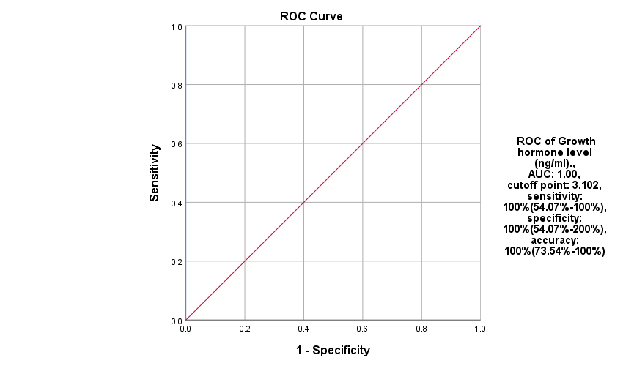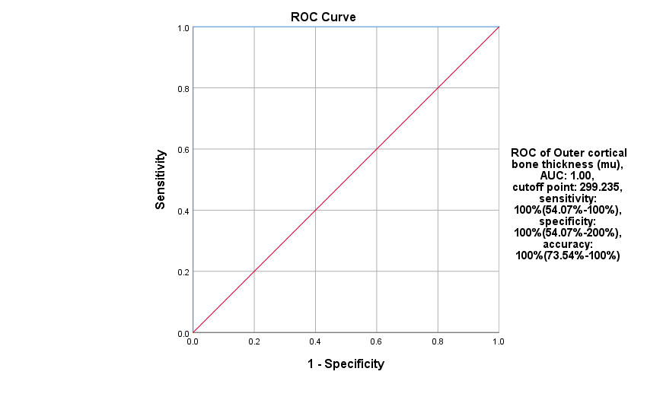

Figure 2: ROC curve of tibial length 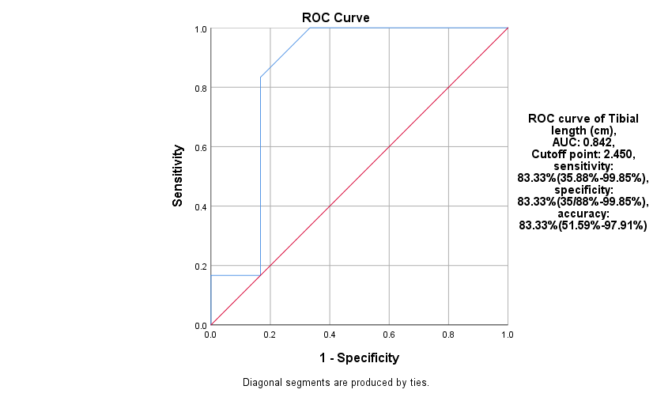

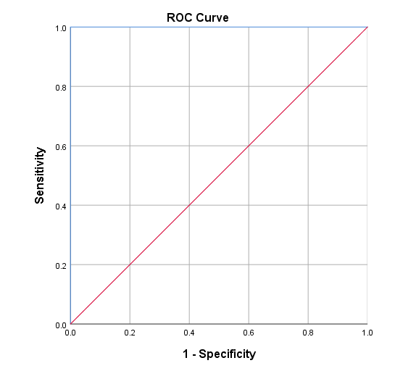

Figure 5: ROC curve of osteoclast count

Figure 3: ROC curve of outer cortical bone thickness

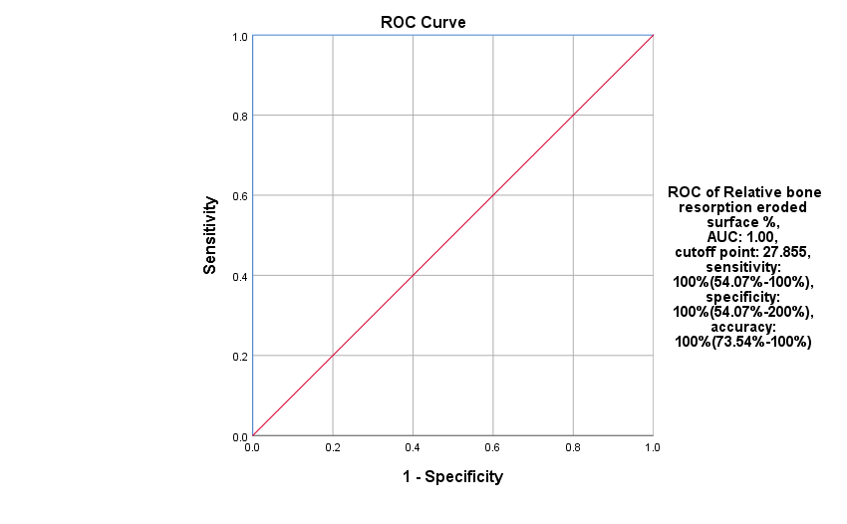

Figure 4: ROC curve of relative bone resorption eroded surface %

|  |  |
| --- | --- |
| (A) Photomicrograph of H&E stained section of rat tibia of negative control group (after three days) showing a normal outer portion of a dense connective tissue layer as compact bone (CB) from endosteum of the epiphysis with mineralized extracellular bony matrix (CB matrix) consists of collagen fiber and haversian system in a circular pattern including haversian canals surrounded by the osteocytes (Os.c) with characteristic nuclei with the presence of osteoblast cells, osteoclast cells (Os.Cl), vascular supply (Bl.vs) and resorption canals indicating an active process of bone remodeling (scale bar= 100µm). | (B) Photomicrograph of H&E stained section of rat tibia of the negative control group (after ten days) showing normal spongy or cancellous bone (SB) in the epiphysis with a three-dimensional structure consisting of branching anastomosing trabeculae (T), with the same structural organization and components as compact bone. Bone marrow (BM) mainly comprises adipocytes and fills space among trabeculae. Normal compact bone (CB) with vascularity (Bl.vs) is present. (scale bar= 100µm). |
| (C) Photomicrograph of H&E stained section of rat tibia of the positive control group (received corn oil, after three days) showing normal compact bone of diaphysis (CB) with normal regular mineralized bony matrix with collagen fiber and arranged osteocytes (Osc) in a circular pattern forming haversian system, formed from osteons, osteoblast cells, osteoclast cells and vascular supply (Bl.vs). Bone marrow (BM) formed from adipocyte cells in the diaphyseal center is seen (scale bar= 100µm). | (D) Photomicrograph of H&E stained section of rat tibia of the positive control group (received corn oil, after seven days) showing normal cancellous bone of epiphysis with an anastomosing network of trabecular bone (thin arrows) (T) in the form of bone spicules consists of a dense layer of organized, compact bone with arranged osteocytes (Osc) in haversian system forming osteons. Bone marrow (BM) with numerous adipocytes-filled trabecular centers (thick arrows) (scale bar= 100µm). |

**Figure 6: Control group (Negative and Positive)**

|  |  |
| --- | --- |
| (A) Photomicrograph of H&E stained section of rat tibia of ATRA treated group (3 days post-treatment) showing apparently normal regular growth pattern of trabecular bone (T), which is branching and anastomosing with bony matrix, formed from collagen and osteocytes (OSC). Enclosed bone marrow (BM) formed from adipocytes is seen (scale bar= 100µm). | (B) Photomicrograph of H&E stained section of rat tibia of ATRA treated group (3 days post-treatment), showing regular growth pattern through endochondral bone formation type from less wider epiphyseal plate and dark basophilic epiphyseal line (EP.L) with trabeculae (T) enclosed bone marrow (BM) formed from adipocytes and with hyperplasia of osteocytes (Osc) in compact bone. Chondrocytes were seen as regularly arranged columnar cells (scale bar= 100 µm). |
| (C) Photomicrograph of H&E stained section of rat tibia of ATRA treated group (7 days post-treatment), showing regular cartilage replacement by normal regular ossification, vessels formation (Bl.vs) with anastomosing branching trabeculae and compact bone with haversian system with surrounding bone marrow (BM), osteocytes (OSC) and dark basophilic epiphyseal line (EP.L) is present. (black arrow) (scale bar= 100µm). | (D) Photomicrograph of H&E stained section of rat tibia of ATRA treated group (7 days post-treatment), showing apparently normal regular growth pattern towards epiphyseal line (EP.L) with branching anastomosing trabeculae (T) enclosed interrupted bone marrow (BM) with adipocytes. (scale bar= 100 µm). |
| (E) Photomicrograph of H&E stained section of rat tibia of ATRA treated group (10 days post-treatment), showing compact bone (CB) of lateral epiphysis with an increased number of resorption canals (thin arrows) containing blood vessels (Blvs), osteoclasts as multinucleated cells with collagen deposition of mineralized bony matrix including osteocytes (Osc) (thick arrow) (scalebar= 100 µm). | (F) Photomicrograph of H&E stained section of rat tibia of ATRA treated group (10 days post-treatment), showing restricted normal pattern of endo cartilage bone ossification with irregularly arranged chondrocytes(Ch.c) (thin arrows) and osteocytes (OSC) without clear demarcation of the proliferative and hypertrophic zones with wide separated spongy bone (SB) has basophilic patches of bony matrix and enclosed bone marrow (BM) with adipocytes (scale bar= 100 µm). |

Figure 7: the ATRA-treated Group

# **Discussion**

In 1995, the U.S. Food and Drug Administration (FDA) approved the oral administration of pharmacological ATRA for the treatment of acute promyelocytic leukemia (APL). This resulted in a significant improvement in outcomes, with an average overall survival approaching 95% in contemporary practice. Currently, ATRA remains the recommended treatment for APL [7]. The present study aimed to evaluate the impact of ATRA on the growth of the rat tibia .  
Our study demonstrated several effects of ATRA on demonstrated several effects of ATRA on bone growth, including enhanced osteoclastogenesis, decreased growth hormone levels, and aberrant chondrogenesis.  
Growth hormone (GH) is a peptide secreted by the anterior pituitary gland that is crucial for regulating cell division, growth, and metabolism in various targeted organs [13].

Compared to the control groups (positive and negative), the present study revealed a significant reduction in serum growth hormone levels in the ATRA-treated groups. This finding aligns with results indicating that rats administered ATRA demonstrated a substantial decrease in serum GH levels.

Maliza et al. [14] found that ATRA enhances the effects of ghrelin and growth hormone-releasing hormone (GHRH) on GH secretion from the anterior pituitary gland, indicating that differences in the age and duration of treatment of the rats used in their studies may account for the discrepancies observed. In the present study, the mean weight of Group IIIc (ATRA treated for ten days) was significantly lower than that of groups IIIa (ATRA treated for three days) and IIIb (ATRA treated for seven days). These results align with Shen et al. [3], who observed decreased body weight in rats that received ATRA.

According to Guo et al. [15], ATRA’s ability to reduce weight is attributed to its ability to increase thermogenesis and energy expenditure. ATRA increases the expression of lipogenic genes in adipose tissue while also increasing the expression of lipogenic genes in adipose tissue. These findings suggest a feed-forward loop encompassing lipogenesis, lipolysis, and fatty acid oxidation. Nevertheless, Felipe et al. [16] showed that the oral administration of ATRA results in weight gain in rats by inhibiting the expression of resistin in adipocytes. There are various potential reasons for this discrepancy, including variations in animal models and doses. In the investigation, male rats aged 12 weeks received a single subcutaneous injection of ATRA daily for four days before euthanasia at doses of 10, 50, or 100 mg/kg body weight, aligning with the current study's findings.

According to Cardoso-Demartini et al. [17], ATRA may induce developmental damage by facilitating an early fusion of the growth plates, which accounts for the observed reduction in tibial length and nose-tail length. Shen et al.’s [3] investigation clarified the reduction in investigated the reduction in tibial length and nose-tail length. High levels of ATRA induce bone marrow hypoxia, potentially exacerbating bone injury and inhibiting the transduction of the insulin growth factor 1 (IGF1) signal, as ATRA effectively induces p53 in various cell types. The IGF signal axis and p53 signaling pathway exhibit a significant relationship. Numerous studies indicate that p53 can inhibit the promoter of IGF1R, thereby suppressing IGF1 signaling and diminishing survival signals. This interaction may enhance osteoclast activity and lead to insulin growth factor-binding protein 3 (IGFBP3) resistance. In this study, three-week-old male rats were utilized and subjected to a 10-day treatment of high-dose ATRA administered via gavage. Subsequently, the tibial and nasal-tail lengths of the experimental rats were reduced compared to the controls.

Lionikaite et al. [18] found that short-term ATRA supplementation reduced outer cortical bone thickness because it increased the number of osteoclasts. This finding is consistent with their findings. In a similar vein, Lerner [19] discovered that ATRA promotes bone growth on endocortical surfaces while decreasing bone resorption. The current investigation demonstrated a significant increase in osteoclast numbers and the relative percentage of degraded bone resorption when comparing the ATRA-treated groups to the control groups.

This result was supported by studies conducted by V Lionikaite et al. [18], who found that the number of osteoclasts on the periosteal surface of the long bones in rats was significantly increased by short-term ATRA supplementation.

Rats treated with high-dose ATRA appear to encourage osteoblast development, but low-dose ATRA therapy appears to have the reverse effect Alloisio et al. [23]. Yu et al. [24] reported that low concentrations of ATRA enhanced the expression of osteoblast-related genes, including osteocalcin (OCN), alkaline phosphatase (ALP), and vascular endothelial growth factor (VEGF). Additionally, ATRA significantly inhibited the expression of osteoclast-related genes, reduced their resorption activities, and facilitated the differentiation of osteoblasts.  
The histological examination of the tibial bone sample confirmed the growth measurements, histomorphometric analysis, and biochemical assessment of blood growth hormone. The analysis indicated that ATRA administration led to increased resorption canals and a higher count of osteoclasts. The findings revealed a restricted normal endochondral ossification pattern characterized by erratically arranged chondrocytes and widely separated trabecular bone. The resting, proliferative, and hypertrophic zones lacked clear definition, while the enclosed bone marrow, containing adipocytes, was encircled by basophilic patches of bony matrix.

Future research should focus on examining the various effects of ATRA on bone and provide recommendations for its safer application as a chemotherapy agent for pediatric patients.

**Conclusions:** High-dose administration of ATRA led to a decrease in growth measurements, including weight, tibial length, and nose-tail length. Oral administration of ATRA at high doses for ten days results in tibial bone resorption, as evidenced by various histological alterations and histomorphometric changes. Therefore, using ATRA as a chemotherapy must be carefully adapted to the treatment protocol.

**Recommendations:** In order to assess the toxic effects of ATRA on bone, it is necessary to conduct precise records of the incidence and prevalence of affected cases as a result of ATRA treatment regimens in oncology hospitals and institutes. Additional experimental studies are required to adjust the exact regimen of ATRA for the treatment of acute promyelocytic leukemia (APL) and neuroblastoma (NB) in children, as well as clinical studies.

**Study limitations :**

Limited research has examined the toxic effects of ATRA on different organs on various organs.

**Acknowledgment:** The authors express gratitude to the technical and cooperative staff at the Pathology departments of Zagazig University and the Central Lab of Veterinary Medicine, Egypt, for their support throughout the study.

**Financial support and sponsorship:** Nil

**Conflict of Interest:** Nil

References

1. Gomes CC, Passos TS, Morais AHA. Vitamin A Status Improvement in Obesity: Findings and Perspectives Using Encapsulation Techniques. Nutrients. 2021;13.

2. Berihun B, Chemir F, Gebru M, GebreEyesus FA. Vitamin A supplementation coverage and its associated factors among children aged 6-59 months in West Azernet Berbere Woreda, South West Ethiopia. BMC Pediatr. 2023;23:257.

3. Shen Q, Wang X, Bai H, Tan X, Liu X. Effects of high-dose all-trans retinoic acid on longitudinal bone growth of young rats. Growth Horm IGF Res. 2022;62:101446.

4. Bahlool AZ, Grant C, Cryan SA, Keane J, O'Sullivan MP. All trans retinoic acid as a host-directed immunotherapy for tuberculosis. Curr Res Immunol. 2022;3:54-72.

5. Szymański Ł, Skopek R, Palusińska M, Schenk T, Stengel S, Lewicki S, et al. Retinoic Acid and Its Derivatives in Skin. Cells. 2020;9.

6. Wang S, Bi W, Liu Y, Cheng J, Sun W, Wu G, et al. The Antagonist of Retinoic Acid Receptor α, ER-50891 Antagonizes the Inhibitive Effect of All-Trans Retinoic Acid and Rescues Bone Morphogenetic Protein 2-Induced Osteoblastogenic Differentiation. Drug Des Devel Ther. 2020;14:297-308.

7. Giuli MV, Hanieh PN, Giuliani E, Rinaldi F, Marianecci C, Screpanti I, et al. Current Trends in ATRA Delivery for Cancer Therapy. Pharmaceutics. 2020;12.

8. Ferla V, Sciumé M, Gianelli U, Baldini L, Fracchiolla NS. Multiple adverse drug reactions during all-trans retinoic acid treatment for acute promyelocytic leukemia: differentiation syndrome, bradycardia, intestinal necrosis. Explor Target Antitumor Ther. 2020;1:109-16.

9. Usategui-Martín R, Pérez-Castrillón JL. Animal Experimental Models in Bone Metabolic Disease. Int J Mol Sci. 2023;24.

10. Ashraf S, Zaneb H, Yousaf MS, Ijaz A, Sohail MU, Muti S, et al. Effect of dietary supplementation of prebiotics and probiotics on intestinal microarchitecture in broilers reared under cyclic heat stress. J Anim Physiol Anim Nutr (Berl). 2013;97 Suppl 1:68-73.

11. Liang C, Qiao G, Liu Y, Tian L, Hui N, Li J, et al. Overview of all-trans-retinoic acid (ATRA) and its analogues: Structures, activities, and mechanisms in acute promyelocytic leukaemia. Eur J Med Chem. 2021;220:113451.

12. Masetti R, Muratore E, Leardini D, Baccelli F, Pession A, Prete A, et al. Chemotherapy-free treatment for acute promyelocytic leukemia: the pediatric view of a revolutionary tale. Front Oncol. 2023;13:1135350.

13. Chang CW, Sung YW, Hsueh YW, Chen YY, Ho M, Hsu HC, et al. Growth hormone in fertility and infertility: Mechanisms of action and clinical applications. Front Endocrinol (Lausanne). 2022;13:1040503.

14. Maliza R, Fujiwara K, Tsukada T, Azuma M, Kikuchi M, Yashiro T. Effects of retinoic acid on growth hormone-releasing hormone receptor, growth hormone secretagogue receptor gene expression and growth hormone secretion in rat anterior pituitary cells. Endocr J. 2016;63:555-61.

15. Guo H, Foncea R, O'Byrne SM, Jiang H, Zhang Y, Deis JA, et al. Lipocalin 2, a Regulator of Retinoid Homeostasis and Retinoid-mediated Thermogenic Activation in Adipose Tissue. J Biol Chem. 2016;291:11216-29.

16. Felipe F, Bonet ML, Ribot J, Palou A. Modulation of resistin expression by retinoic acid and vitamin A status. Diabetes. 2004;53:882-9.

17. Demartini A, Boguszewski C, Boguszewski M. Potential Effects of Oral Isotretinoin on Growth Plate and Height. Endocrines. 2023;4:281-92.

18. Lionikaite V, Gustafsson KL, Westerlund A, Windahl SH, Koskela A, Tuukkanen J, et al. Clinically relevant doses of vitamin A decrease cortical bone mass in mice. J Endocrinol. 2018;239:389-402.

19. Lerner UH. Vitamin A - discovery, metabolism, receptor signaling and effects on bone mass and fracture susceptibility. Front Endocrinol (Lausanne). 2024;15:1298851.

20. Henning P, Westerlund A, Horkeby K, Lionikaite V, Nilsson KH, Movérare-Skrtic S, et al. Vitamin A enhanced periosteal osteoclastogenesis is associated with increased number of tissue-derived macrophages/osteoclast progenitors. J Biol Chem. 2024;300:107308.

21. Henning P, Conaway HH, Lerner UH. Retinoid receptors in bone and their role in bone remodeling. Front Endocrinol (Lausanne). 2015;6:31.

22. Bi W, Liu Y, Guo J, Lin Z, Liu J, Zhou M, et al. All-trans retinoic-acid inhibits heterodimeric bone morphogenetic protein 2/7-stimulated osteoclastogenesis, and resorption activity. Cell Biosci. 2018;8:48.

23. Alloisio G, Ciaccio C, Fasciglione GF, Tarantino U, Marini S, Coletta M, et al. Effects of Extracellular Osteoanabolic Agents on the Endogenous Response of Osteoblastic Cells. Cells. 2021;10.

24. Yu Z, Yuan Y, Ma Y, Jiang L, Zhou Y, Bi W. Research Progress of Combined Application of All-trans Retinoic Acid and Bone Morphogenetic Protein in Bone Metabolism. International Journal of Biology and Life Sciences. 2023;3:14-7.

تأثيرات الجرعة العالية لحمض الرتينويك المفروق علي نمو عظمة القصبة في الفئران البيضاء الذكور الغير بالغة

ندى خالد عاطف عيسى *، إبراهيم سيد أحمد زمزم ، مها محمد مختار، مروة محمد مراد ، نجاح السيد محمد علي

قسم الطب الشرعي والسموم الإكلينيكية، كلية الطب، جامعة بنها، بنها، مصر.*

**الخلفية: حمض الريتينويك المفروق (ATRA) هو مستقلب للكحول و فيتامين أ , ويلعب دورًا كبيرًا في تنظيم مجموعة متنوعة من العمليات الفسيولوجية، مثل تمايز الخلايا الظهارية , وتطوير الأجنة. يهدف هذا البحث إلى تقييم تأثير الجرعات العالية من s(ATRA) على نمو عظمة القصبة من خلال الفحص النسيجي وتحليل القياسات النسيجية وقياس مستويات هرمون النمو في الدم لدى ذكور الفئران البيض الصغار.**

**الطرق: شملت الدراسة التجريبية أربعة وخمسين من ذكور الفئران البيضاء الصغار، والتي تم تقسيمها عشوائيًا إلى تسع مجموعات، كل مجموعة مقسمة إلى ثلاث مجموعات فرعية تحتوي كل منها على ستة فئران. عملت المجموعات I و II كمجموعات تحكم، بينما تلقت المجموعة III علاجًا بجرعات عالية من ATRA). تمت الموافقة على البحث من قبل لجنة**

**الأخلاقيات البحثية في كلية الطب بجامعة بنها.**

**النتائج: أظهرت الدراسة أن علاج (ATRA) أدى إلى انخفاض كبير في مستوى هرمون النمو في الدم (P=0.000) وتقليص في الوزن (P<0.05 إلى P=0.001)، وطول عظمة القصبة (P<0.05)، وطول الأنف إلى الذيل (P<0.05)، وسمك القشرة العظمية الخارجية (P=0.000). بالإضافة إلى ذلك، لوحظ زيادة كبيرة في نسبة سطح الامتصاص العظمي النسبي (P=0.000) وعدد الخلايا الآكلة للعظم (P=0.000) في مجموعات علاج ATRA. لم تُلاحظ اختلافات ملحوظة بين مجموعات التحكم أو في عدد الخلايا العظمية عبر جميع المجموعات.**

**الاستنتاجات: تؤدي الجرعات العالية من (ATRA) إلى زيادة امتصاص العظام في عظمة القصبة وتسبب تغييرات نسيجية وتسمم في الأنسجة العظمية. يؤدي تناول (ATRA) عن طريق الفم لمدة عشرة أيام بجرعات عالية إلى تأثيرات سلبية كبيرة على نمو عظمة القصبة وسلامتها الهيكلية.**